PRACTICE 4
Determine the validity of the following three statements. Circle either True or False.
1. Group functions work across many rows to produce one result per group.
True/False True
2. Group functions include nulls in calculations.
True/False False
    - The WHERE clause restricts rows prior to inclusion in a group calculation.
True/False True
The HR department needs the following reports:
4. Find the highest, lowest, sum, and average salary of all employees. Label the columns
Maximum, Minimum, Sum, and Average, respectively.
ANS - Select max(salary) Maximum,min(salary) Minimum,sum(Salary) Sum, avg(nvl(salary,0)) Average
From employees;
- Modify the query in lab_04 to display the minimum, maximum, sum, and average salary for each job type.
ANS - Select job_id, max(salary) Maximum,min(salary) Minimum,sum(Salary) Sum, avg(nvl(salary,0)) Average
From employees
Group by job_id;
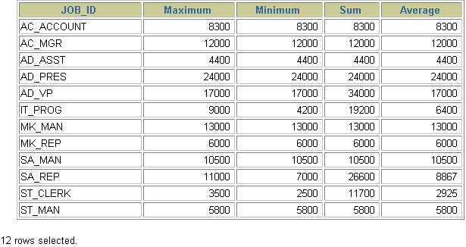
- Write a query to display the number of people with the same job.
ANS - select job_id,count(job_id) "COUNT(*)"
From employees
Group by job_id ; 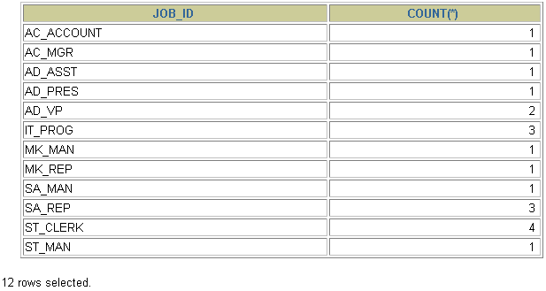
- Determine the number of managers without listing them. Label the column Number of Managers.

ANS - select count(distinct manager_id) "Number of Managers"
from employees
8.Find the difference between the highest and lowest salaries. Label the column DIFFERENCE.
ANS - select max(salary)-min(salary) "DIFFERENCE"
FROM employees

